**Arabic letters classification**

First:Discuss your model

Model consists of convolutional layers, batch normalization, max pooling, dropout, and a global average pooling layer followed by a dense layer with softmax activation for classification. It's designed for image classification tasks with grayscale images of size (160, 160, 1). The output layer has 65 units since you have 65 classes. The total number of trainable parameters is 108,985.

**Conv2D (Convolutional Layer):**

Description: This layer performs convolution operations on the input data. It uses filters (small matrices) to slide over the input image and extract features.

Parameters:

filters=16: Number of filters in the convolutional layer.

kernel_size=3: Size of the filters (3x3 in this case).

padding='same': Padding added to the input to preserve spatial dimensions.

input_shape=(160, 160, 1): Input shape of the layer (160x160 pixels, 1 channel for grayscale).

kernel_initializer='he_normal': Weight initialization method.

activation='relu': Rectified Linear Unit activation function.

**BatchNormalization:**

Description: Normalizes the activations of the previous layer, helping with faster convergence and improved generalization.

Parameters:

axis=-1: Specifies the axis along which normalization is applied (channel axis in this case).

**MaxPooling2D:**

Description: Performs max pooling on the input, reducing spatial dimensions and retaining important features.

Parameters:

pool_size=2: Size of the max pooling window.

**Dropout**:

Description: Introduces dropout to prevent overfitting. During training, a fraction of input units is randomly set to zero at each update.

Parameters:

rate=0.2: Fraction of the input units to drop.

(Repeat Blocks 1-4):

These blocks repeat the pattern of Conv2D, BatchNormalization, MaxPooling2D, and Dropout with increasing filter size (16, 32, 64, 128).

**GlobalAveragePooling2D:**

Description: Computes the average value of each feature map in the previous layer. Reduces spatial dimensions to a 1D tensor.

Parameters:

No specific parameters, as it performs a global average pooling operation.

**Dense (Fully Connected) Layer:**

Description: The final fully connected layer for classification.

Parameters:

units=65: Number of output units, corresponding to the number of classes.

activation='softmax': Softmax activation function, suitable for multi-class classification.

Overall, the architecture follows a pattern of convolutional feature extraction, spatial reduction through pooling, and regularization through dropout. The final layers aggregate information for classification. The choice of activation functions, initializers, and other hyperparameters can be adjusted based on experimentation and problem requirements.

Second:loss fun

**Categorical Crossentropy Loss:**

Definition: Categorical Crossentropy is a commonly used loss function for multi-class classification problems.

Use Case: Appropriate for scenarios where each input belongs to one and only one class (exclusive classes).

**Mathematical Formulation:**

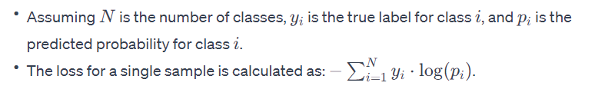

**Interpretation:**

The loss is low when the predicted probabilities align well with the true labels.

It penalizes the model more for confidently incorrect predictions.

**Softmax Activation and Categorical Crossentropy:**

Often used together in the output layer for multi-class classification.

Softmax ensures that the predicted values are probabilities (sum to 1), and categorical crossentropy compares these probabilities to the true one-hot encoded labels.

**confusion matrix:**

would have 65 rows and 65 columns, each element representing the count of instances falling into a specific combination of true and predicted classes. Analyzing this matrix provides insights into how well the model is performing for each class.

**Loss and Accuracy curve:**

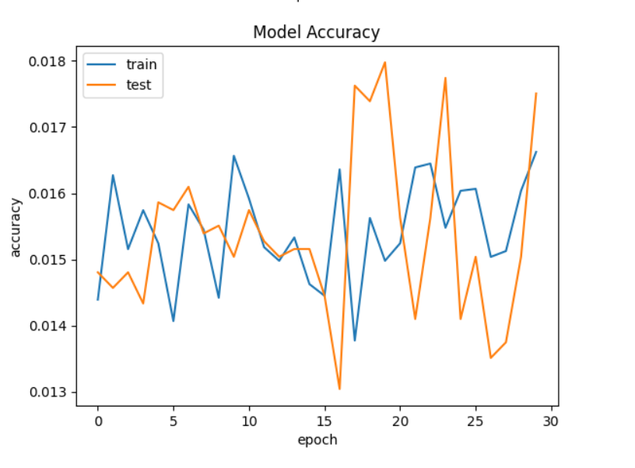

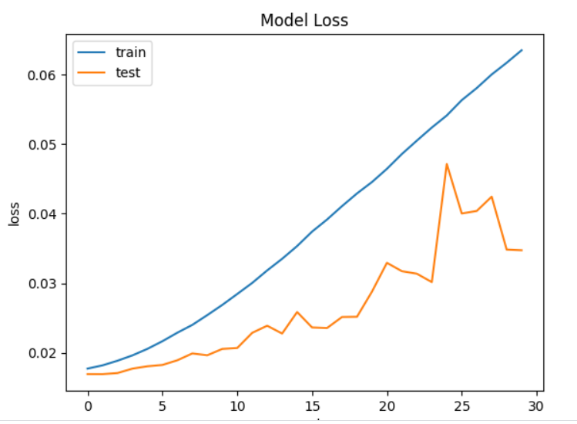

**Name:Eman Saad Mohamed**

**ID:320210042**